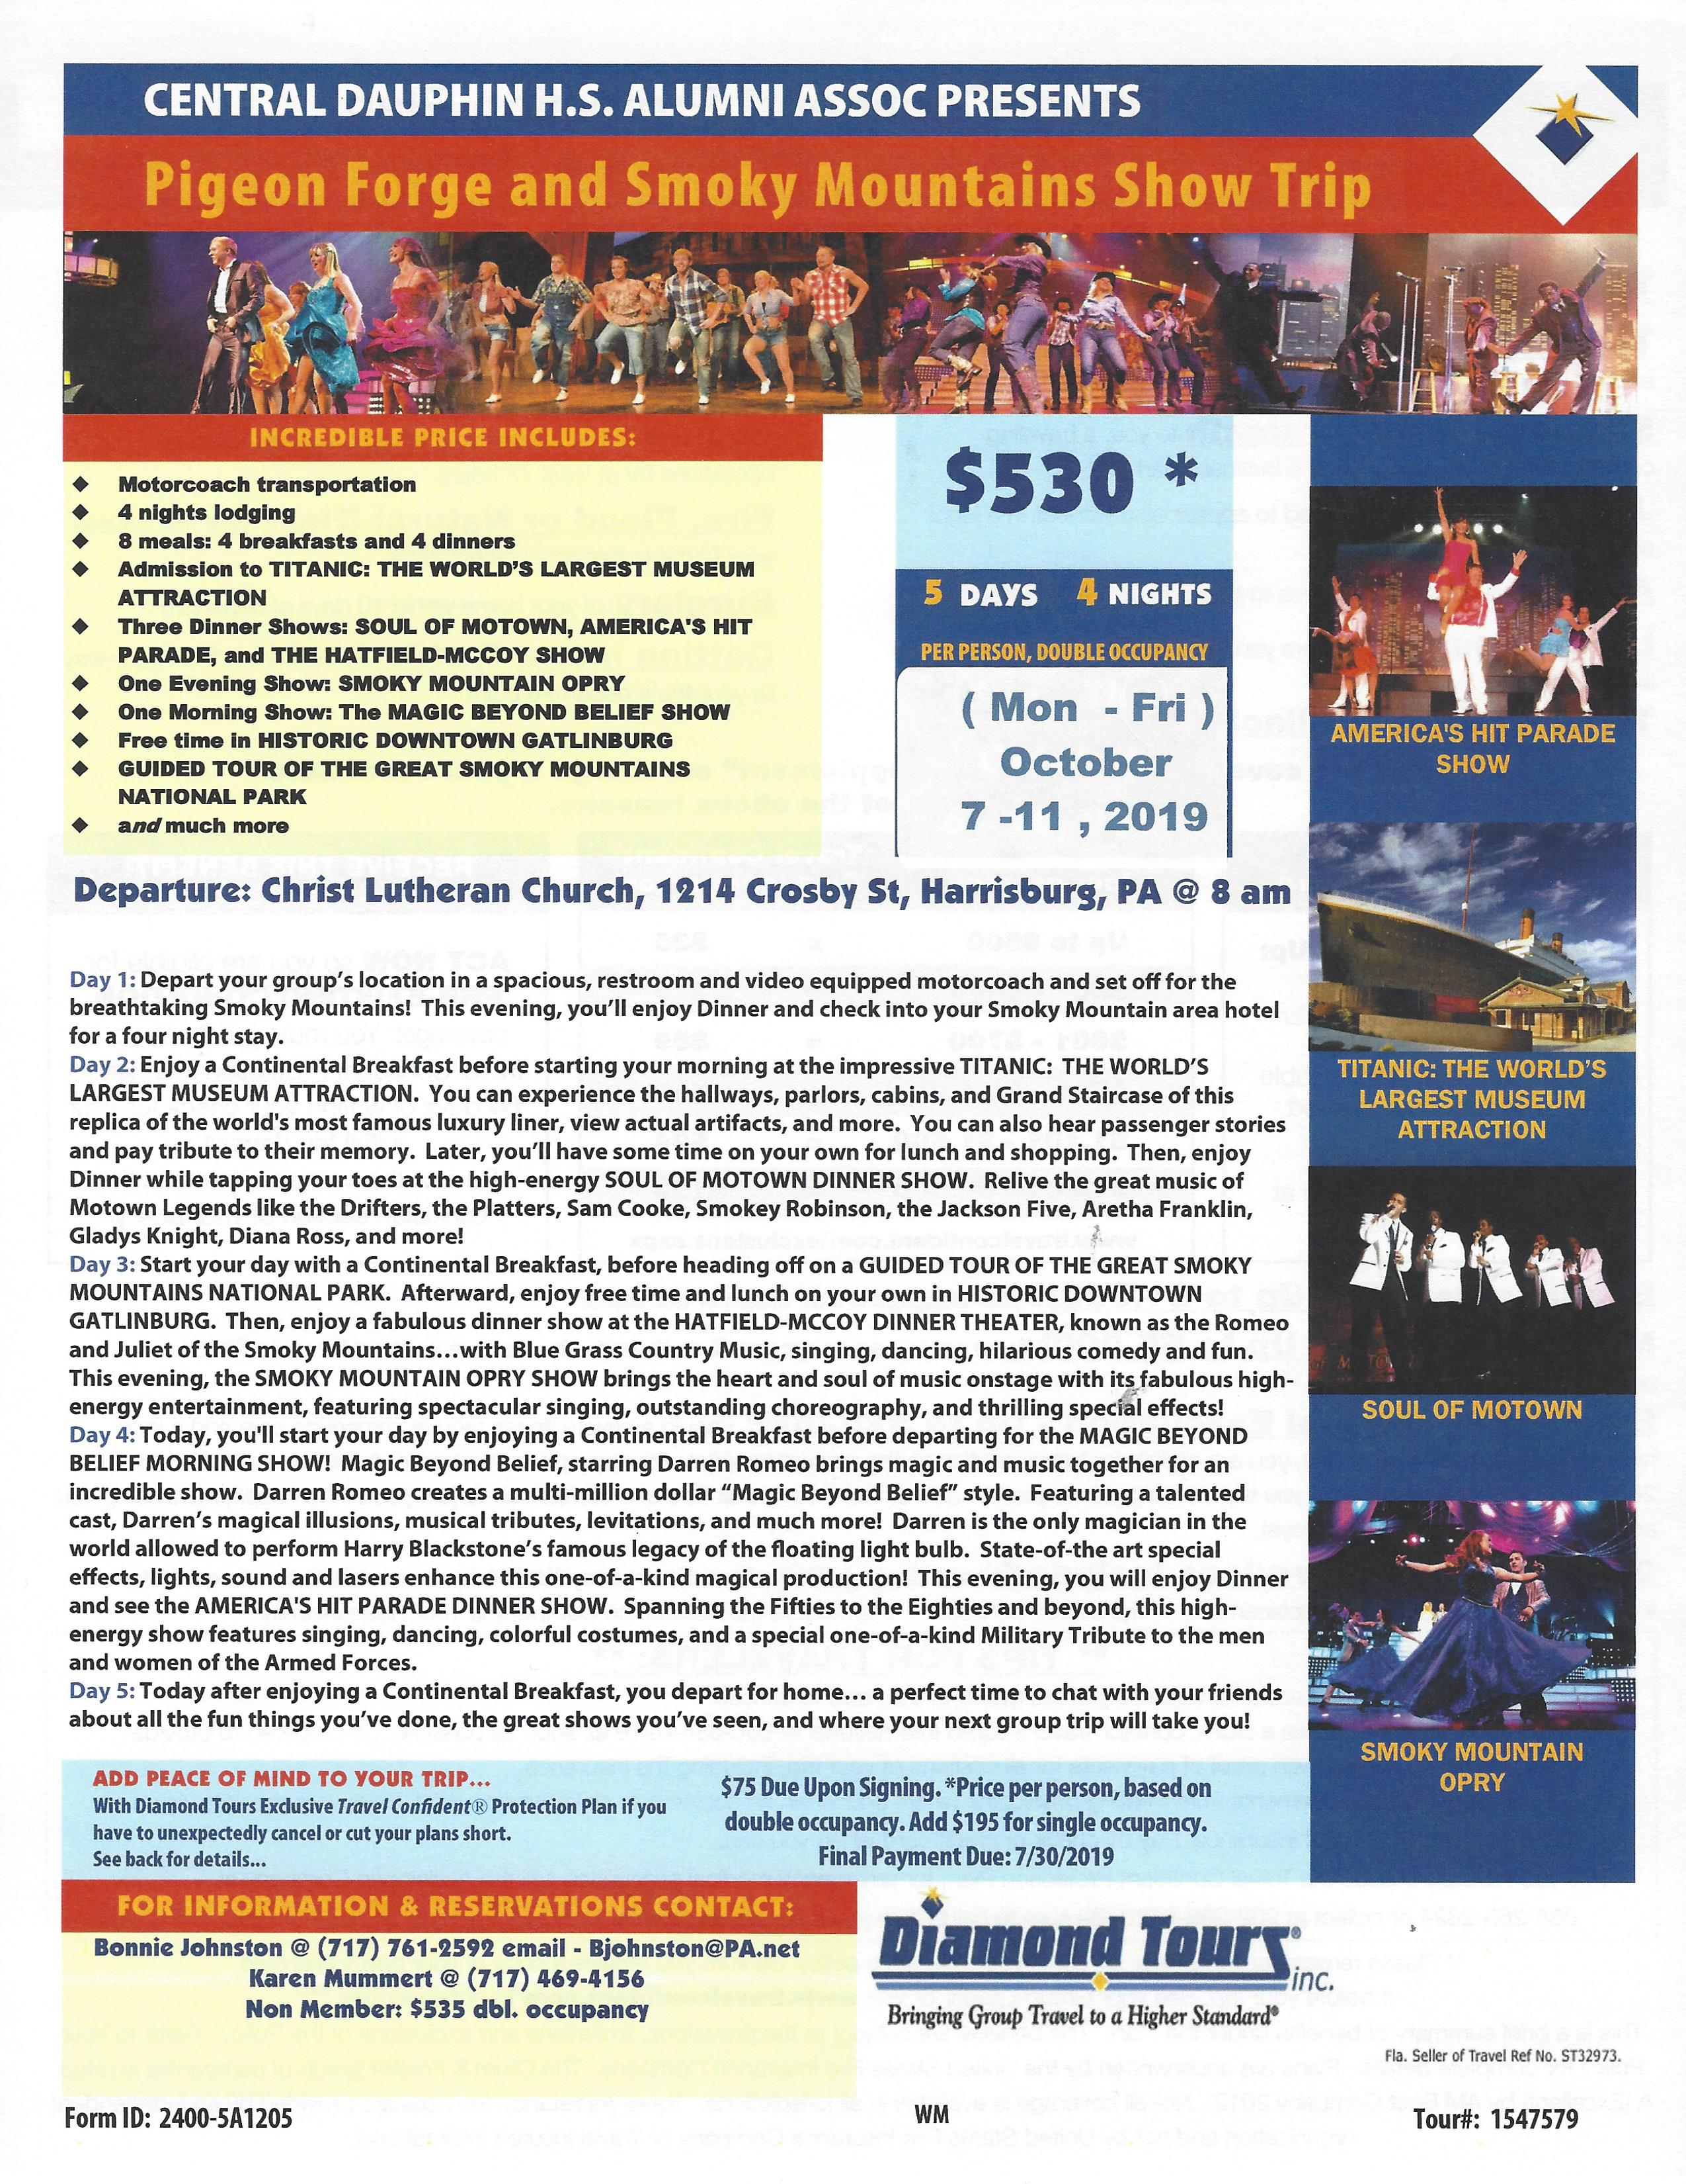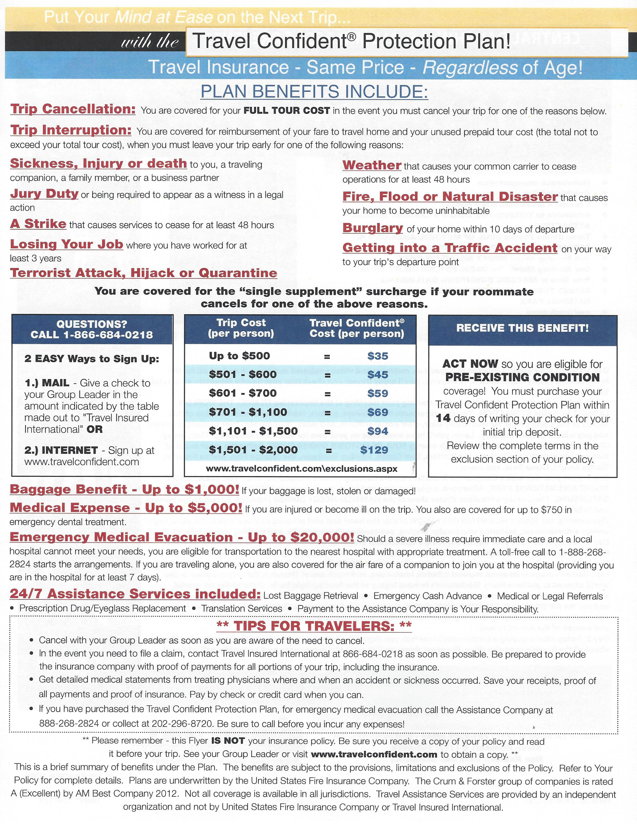
The CDHSAA
Pigeon Forge and
Smoky Mountains Show Trip
Visit Pigeon Forge, Gatlinburg, and the Smoky Mountains
5 Days – 4 nights, October 7 -11, 2019
Trip Registration Form
For trip details or questions see the attached flyer or Contact: Bonnie Johnston - (717}761-2592;
Cell (717) 991-2296; email bjohnston@pa.net or call Karen Mummert - (717) 469-4156.
Please make all payments by check - payable to: CDHSAA
Complete this form and mail it along with your deposit or full payment to:
Bonnie Johnston
6207 Lookout Drive
Mechanicsburg, PA 17050
---------------------------------------------- Cut here -------------------------------------------------------------------
Name: *__________________________________________________ *
Address: _____________________________ City:________________ State_____ Zip:________ Home Phone______________ Cell Phone _____________
Email: _________________________
My Roommate's Name is: _______________________ (for double occupancy hotel rates)

CDHSAA Lifetime Member? Yes _____ ($530 PP rate) No_____ ($535 PP rate)
(Add $195.00 for a SINGLE room)
Total Amount Due: $ ___________________

A $75.00 deposit per person is due by 05/18/19 ____or Payment in Full____ (Check one)
Amount Enclosed: $ ____________ (Make Checks Payable to: CDHSAA)
Balance Due by 07/31/19 (if applicable): $ __________
(Refundable if cancelled 2 weeks before departure)

EMERGENCY Contact –
(Please list a Name & Phone # of someone not traveling with you)

Please indicate any Special Needs Request or Dietary Restrictions:
_______________________________________________________________________________
*(Note: *One form per traveler is required unless all information is the same for both people)

